

**Epoka University**

**Faculty of Engineering and Architecture Department of Computer Engineering CEN302 – Software Engineering**

***Epoka Dental Clinic* Requirements Specification   June , 2024**

***Epoka Dental Clinic Documentation***

***Epoka Dental Clinic Requirements Specification***

***June, 2025***

Prepared by:

Luis Seferaj

Erli Halili

Gesjan Celiku

Flori Topciu

Fatjon Begaj

Frensis Karaj

**Table of Contents**

**1. EXECUTIVE SUMMARY......................................................................................... 5**

1.1 PROJECT OVERVIEW ............................................................................................... 5

1.2 PURPOSE AND SCOPE OF THIS SPECIFICATION ....................................................... 6

**2. PRODUCT/SERVICE DESCRIPTION ....................................................................... 7**

2.1 PRODUCT CONTEXT................................................................................................. 7

2.2 USER CHARACTE.ICS .............................................................................................. 8

2.3 ASSUMPTIONS......................................................................................................... 9

2.4 CONSTRAINTS.......................................................................................................... 10

**3. REQUIREMENTS..................................................................................................12**

3.1 FUNCTIONAL REQUIREMENTS ............................................................................... 12

3.2 NON-FUNCTIONAL REQUIREMENTS ...................................................................... 14

*3.2.1 Product Requirements........................................................................................ 14*

3.2.1.1 User Interface Requirements............................................................................ 14

3.2.1.2 Learnability...................................................................................................... 14

3.2.1.3 Accessibility .................................................................................................... 14

3.2.1.4 Efficiency ........................................................................................................ 14

3.2.1.5 Memorability.................................................................................................... 14

3.2.1.6 Errors............................................................................................................... 15

3.2.1.7 Satisfaction ..................................................................................................... 15

3.2.1.8 Capacity .......................................................................................................... 15

*3.2.2 Organizational Requirements............................................................................... 15*

3.2.2.1 Availability ....................................................................................................... 15

3.2.2.2 Latency …......................................................................................................... 15

3.2.2.3 Monitoring........................................................................................................ 16

3.2.2.4 Maintenance..................................................................................................... 16  
3.2.2.5 Operations........................................................................................................16

3.2.2.6 Standards Compliance...................................................................................... 16

3.2.2.7 Portability ......................................................................................................... 17

*3.2.3 External Requirements......................................................................................... 17*

3.2.3.1 Security............................................................................................................. 17

3.2.3.2 Protection.......................................................................................................... 17

3.2.3.3 Authorization and Authentication........................................................................ 18

3.3 DOMAIN REQUIREMENTS ........................................................................................ 18

**4. SOFTWARE DESIGN / DIAGRAMS........................................................................16**

4.1 REQUIREMENTS ANALYSIS .................................................................................... 16

*4.1.1 User Scenarios................................................................................................... 16*

4.1.1.1 User Scenarios List.......................................................................................... 16

4.1.1.2 User Scenarios Extended.................................................................................. 24

*4.1.2 User Cases......................................................................................................... 30*

4.2 BEHAVIORAL DIAGRAMS........................................................................................ 37

*4.2.1 Use Case Diagrams ............................................................................................ 37*

*4.2.2 Activity Diagrams................................................................................................ 39*

*4.2.4 Sequence Diagrams........................................................................................... 55*

4.3 ENTITY RELATION................................................................................................. 62

*4.3.1 Database Schema Design.................................................................................. 62*

4.4 STRUCTURAL DIAGRAMS ..................................................................................... 63

*4.4.1 Class Diagram ................................................................................................. 63*

*4.4.2 Component Diagrams...................................................................................... 65*

**5. IMPLEMENTATION TECHNOLOGY .......................................................................66**

**6. PROJECT PLANNING..........................................................................................68**

1. EXECUTIVE SUMMARY

1.1 Project Overview

Epoka Dental Clinic is a comprehensive web-based solution designed to revolutionize the way dental clinics manage their patient reservations and appointments. Currently, many healthcare facilities still rely on manual, paper-based processes for handling patient reservations, scheduling appointments, and maintaining patient records. These traditional methods are not only time-consuming and prone to errors but also lack the efficiency and accessibility that modern healthcare providers and patients demand. Epoka Dental Clinic aims to address these challenges by providing a centralized, digital platform that streamlines and automates various aspects of clinic operations, from patient reservations and appointment management to staff administration and reporting. By leveraging the best web technologies, Epoka Dental Clinic offers a user-friendly interface accessible from any device with an internet connection, enabling seamless collaboration and coordination among patients, staff, and clinic managers.

1.2 Purpose and Scope of this Specification

The purpose of this project is to develop a web application that will facilitate the operations of dental clinics in Albania by digitalizing patient records. This application aims to replace hardcopy files, allowing for easier access, better management, and enhanced security of medical records. The system will enable patients to access their medical files online, streamline the medical examination process for doctors. This documentation provides detailed information about the functionalities and features of the software, catering to all users, including doctors, patients, and administrative staff.

2. Product/Service Description

Epoka Dental Clinic is an easy-to-use platform that connects patients with doctors offering great services. The system supports three user types: admin, doctor, and client, each with different views and functions. Clients and doctors can create accounts and log in using an email and password, while admins are already set up in the system. Doctors must be approved by admins before listing services to ensure client safety. Users can change their email and password but not their name.

Guests can search for services using filters for rating, type, and date, making it easy to find the perfect one. Booking is straightforward, and clients can pay securely with a credit card.

Both clients and doctors are rated, helping ensure high-quality experiences. Clients and doctors can report each other for issues, and admins can take actions like fines or bans to keep the community safe. Doctors can manage their services, update information, and track earnings through the app. Clients can save favorite.

Automated emails keep users informed about bookings, payments, and account actions. The admin dashboard shows overall earnings from bookings. The interface is clean and adapts to various devices, with clear error messages and easy navigation.

Epoka Dental Clinic is designed to handle many users and transactions simultaneously, ensuring it works smoothly even at peak times. It promises high availability and strong security, with encrypted data and regular security checks to protect user information. Overall, Epoka Dental Clinic offers a reliable and enjoyable platform for patients and doctors.

*2.1 Product Context*

For Clients:

Clients can search and filter properties by rating, type, and date. Booking and payment are handled securely within the app. Guests can save favorites, view booking history, and receive automated notifications. Ratings and reviews help ensure high-quality experiences.

For Doctors:

Doctors can list, edit, and manage services, track bookings, and see earnings through a dashboard. Doctors must be approved by admins to ensure client safety.

For Admins:

Admins oversee the platform, approve doctors, manage reports and disputes, and monitor financial performance through an admin dashboard. They ensure community safety by reviewing user reports.

Security and Performance:

Epoka Dental Clinic encrypts user data and conducts regular security audits. It handles high volumes of users and transactions, ensuring smooth operation with 99.9% uptime and geographic redundancy.

User Interface:

The interface is intuitive and responsive, adapting to various devices. Clear error messages and easy navigation enhance the user experience. Automated emails keep users informed about important actions and updates.

Overall Vision:

Epoka Dental Clinic aims to create a reliable, secure, and user-friendly platform that enhances travel experiences with unique lodging options and effective property management for hosts.

*2.2 User Characteristics*

There are three types of users that will interact with the system:

1. Client:

* Can log in his account
* Can look at his/her and other’s profile
* Can search for properties to book
* Can view the booking history
* Can mark services as “Favorites” and see the full list
* Can change his account password
* Can pay for a new booking
* Can look at service listings in details
* Can leave a feedback for the doctor
* Can log out

2. Doctor:

* Can log in his account
* Can look at his/her and other’s profile
* Can list services for others to book
* Can view the booking history for each service
* Can change his account password
* Can leave a feedback for the client
* Can see/download the gross/revenue reservations graph
* Can log out

3. Admin:

* Can log in his account
* Can look at other’s profile
* Can accept / decline doctors account
* Can ban a doctor/client
* Can give a fine to a doctor/client
* Can review reports
* Can log out

2.3 Assumptions

Doctor and the manager will receive proper training on how to use the application effectively.

● Clinic has the necessary infrastructure (computers, internet connectivity) to support the

implementation and usage of the web-based PMS application.

● Proper verification and validation of patient and staff details will be performed during data entry

processes to maintain data integrity and accuracy.

● Doctors are responsible for managing their assigned reservations and

updating the status (postponed, concluded) correctly.

● Manager is responsible for maintaining up-to-date information about staff, services within the system.

2.4 Constraints

● The Epoka Dental Clinic application requires a stable and reliable internet connection to function properly, as it is a web-based solution.

● Efficient usage and maximization of the application's capabilities are contingent upon adequate

training and adoption by doctors and the clinic manager.

● The application's performance and reliability are dependent on the availability and proper functioning of the clinic's network infrastructure and IT resources.

● The ability to search for patients and doctors is limited by the accuracy and completeness of

the data entered into the system.

● The application's user interface and functionality may be constrained by the capabilities and

limitations of the web technologies and frameworks used in its development.

2.5 Dependencies

● Creation of new patient reservations is dependent on the availability

(Postponing or marking reservations as concluded is dependent on the availability and participation of doctors.

● Viewing general clinic information on the main page is dependent on the availability and accessibility of the application's main page.

**3. Requirements**

***3.1 Functional Requirements***

| **Req** | **Requirement** | **Comments** | **Priority** | **Date Rvwd** | **SME Reviewed / Approved** |
| --- | --- | --- | --- | --- | --- |
| FR_1 | The system needs to have 3 users and it should  have different views  for different users. | admin/doctor/patient | High | 28/03/2025 | Luis |
| FR_2 | Patients and doctors can log into their account or create new accounts and admin users already exist in the database. | Doctor and patients collaborate together while admin serves as a regulatory. | High | 28/03/2025 | Gesjan |
| FR_3 | User accounts are secured by a password which corresponds to the email(both needed for the log in). | This is how users are differentiated. | Medium | 28/03/2025 | Erli |
| FR_4 | Doctors need to be approved by the admin before they start using their account. | As a safety measure for the patients. | Medium | 28/03/2025 | Luis |
| FR_5 | Each user can change their password or email but not their name and surname. | The accounts are personale thats why the name and surname can not change while email and passwords are changeable information. | Medium | 28/03/2025 | Fatjon |
| FR_6 | Patients will be able to see all doctors and their services and they will be able to use a filter to filter out the services from their location, price and date. | This is how they find the service they need. | High | 28/03/2025 | Flori |
| FR_7 | The patient can book a service if it is free at a certain date and pay for it using a card directly in the app. | The booking is an in app purchase or you can pay by cash when you go to the appointment. | High | 28/03/2025 | Erli |
| FR_8 | A patient can add a service to his favorites. | This makes it easy for the patient to find the service if he wants to book another time. | Medium | 28/03/2025 | Frensis |
| FR_9 | The patient can see all their bookings, the booking status and other information regarding that booking. | It serves as a log book for the patients. | High | 28/03/2025 | Erli |
| FR_10 | Each patient and service will have an in app rating. | This is a good way for the patient to find a good service and the doctor to accept good patients. | Medium | 28/03/2025 | Gesjan |
| FR_11 | If a patient breaks the service rules he is reported by the doctor and if this report is approved by the admin he can get fined, banned and after 3 approved reports the system automatically bans the patient. | It offers a safe environment for the doctors. | High | 28/03/2025 | Luis |
| FR_12 | The patient or the doctor can cancel a booking. | This can happen  after some constraints that will be listed below are fulfilled. | Medium | 28/03/2025 | Fatjon |
| FR_13 | The location of the clinic where the services are provided needs to be displayed on a map in the app. | By doing this the patient can see exactly where the service is located. | Low | 28/03/2025 | Flori |
| FR_14 | A patient can report a doctor and if the admin approves it the doctor gets fired or fined. | It offers a safe environment for the patient. | Medium | 28/03/2025 | Erli |
| FR_15 | Doctors can see all the services that belong to them. | Help the doctor keep track. | Medium | 28/03/2025 | Gesjan |
| FR_16 | Doctor can delete or edit certain info for a service or add a new one and also he can see all the bookings for that service. | Helps the doctor manage his services better. | Medium | 28/03/2025 | Erli |
| FR_17 | |  | | --- | |  |  |  | | --- | | The system must allow clients to generate invoices, make secure payments, and notify them of results. Admins can review transaction history. | | Covers core billing flow with emphasis on user clarity, secure processing, and admin oversight. | High | 28/03/2025 | Luis |
| FR_18 | Doctors and patients can see each other's public information. | It makes the app transparent. | Medium | 28/03/2025 | Flori |
| FR_19 | Every doctor can see in the app the amount of money they have made during the months from their services. | Provides an extra tool for the doctors to measure their performance . | Low | 28/03/2025 | Frensis |
| FR_20 | The admin has a page where he sees all the money that the app has made from the bookings during the month. | Helps the admins see how good the app is doing. | Low | 28/03/2025 | Erli |
| FR_21 | Everytime:   1. a booking is done or canceled, 2. a payments is done, 3. a user is banned or fined,   the users involved get an automated email. | Very helpful because it notifies the users in real time. | Medium | 28/03/2025 | Gesjan |

***Table 1. Functional Requirements***

***3.2 Non-Functional Requirements***

**3.2.1 Product Requirements**

**3.2.1.1 User Interface Requirements**

The user interface must be intuitive and easy to navigate for both doctors and patients.

It should be responsive and maintain consistency across various devices, including desktop and mobile platforms.

Provide clear and concise visual cues to guide users through booking and listing processes.

Ensure that forms and menus are straightforward and easy to understand, with minimal clicks needed for completion.

Offer language and localization options to cater to a diverse, global user base.

**3.2.1.2 Learnability**

The system should be easy to learn for first-time users, with an accessible tutorial or onboarding process.

Provide contextual help and tooltips for complex functionalities.

Offer user guides and FAQs to assist users in understanding key features.

**3.2.1.3 Accessibility**

Epoka Dental Clinic is designed with accessibility in mind, featuring compatibility with screen readers, keyboard navigation, and high contrast mode for visually impaired users.

**3.2.1.4 Efficiency**

The application should perform efficiently, with minimal latency and quick response times.

Optimize database queries and data processing to ensure speedy load times for users.

Streamline processes such as search, booking, and listing to minimize user wait times.

**3.2.1.5 Memorability**

The system should provide memorable, user-friendly interactions that make it easy for users to return and navigate without difficulty.

Utilize consistent design patterns and interfaces for a cohesive experience across the platform.

Offer users the ability to customize certain aspects of their experience for increased familiarity.

**3.2.1.6 Errors**

The application must handle errors gracefully, with clear and helpful error messages.

Errors should be logged for internal tracking and troubleshooting purposes.

Implement fallback mechanisms to ensure smooth operation even in case of minor failures.

**3.2.1.7 Satisfaction**

Ensure a high level of user satisfaction through responsive customer support and reliable service.

Collect and analyze user feedback regularly to identify areas for improvement.

Provide features and services that meet or exceed user expectations.

**3.2.1.8 Capacity**

The platform should scale efficiently to handle increasing numbers of users, listings, and transactions.

Monitor and manage server and database load to prevent slowdowns or outages.

Design the architecture to accommodate future growth in user base and usage without significant performance degradation.

**3.2.2 Organizational Requirements**

**3.2.2.1 Availability**

• The application will be available 24 hours per day, every day.

• The application will be available to everyone who owns a PC  connected to the Internet,  therefore any user can access his data anywhere.

• The application will be developed such that it will not be forced to encounter downtime since  the data used by the users is very sensitive and time-varying.

• Scheduled maintenance on the system shall not affect its functionality. In case of any problem  unscheduled maintenance of the application shall not allow the system to be down for more  than 1 hour.

**3.2.2.2 Latency**

The latency of the web application will depend on:

• Internet connection strength.

• The size of the database.

• The efficiency of the algorithms used to fetch data from the database.

**3.2.2.3 Monitoring**

• The system will be built to be secure and reliable. The user interfaces will be easy and there are many cases where the system crashes.

• Periodic reports shall be generated by the system maintenance group. These reports shall be  used not only to detect problems but also to find possible ways to improve the system.

• Validation of fields will be used, for example when trying to log in, when a new service listing is  added, when the personal information of a doctor,user or a service is  updated, when trying to change a password etc. In these cases when the input does not match  the requirements a specific message will be shown to the user to inform them about the problem  that occurred.

• For most of the possible error scenarios, informative messages will be prepared to be shown to  the user, in order for him to know what the problem is.

**3.2.2.4 Maintenance**

• The system will be developed using MySQL for the database. Therefore,  this platform will be used to maintain the application.

• The application will be developed in modules so it can be easily extended. New modules can be  easily added to the application anytime.

• In case of system malfunction, a system restart should help. If that does not help, then maybe  the server is down, so the maintenance department should be contacted.

• In case of any software update or bug correction, the users will be informed.

**3.2.2.5 Operations**

Epoka Dental Clinic must support high performance and scalability, handling at least 10,000 simultaneous users and 1,000 transactions per second with 99.9% uptime. The system ensures data security with encryption and regular security audits, while maintaining reliability with a target mean time between failures (MTBF) exceeding 10,000 hours. Additionally, it follows regulatory compliance, including GDPR and CCPA, and provides a user-friendly, responsive interface for all devices.

**3.2.2.6 Standards Compliance**

The application must adhere to industry-standard protocols and best practices, including but not limited to security, privacy, and data protection standards such as GDPR (General Data Protection Regulation), CCPA (California Consumer Privacy Act), and HIPAA (Health Insurance Portability and Accountability Act) if applicable.

Follow best practices for API design and data interchange formats (e.g. JSON, XML) to ensure interoperability with other systems and services.

Implement and maintain data encryption standards for both data at rest and data in transit, protecting user information from unauthorized access.

Regularly review and update compliance policies to ensure the platform remains in line with current standards and regulations.

**3.2.2.7 Portability**

• The system will be web-based; therefore, it will operate the same regardless of the operating  system.

• All you need is a computer or mobile phone and an Internet connection.

**3.2.3 External Requirements**

**3.2.3.1 Security**

The information kept in the system’s database is considered to be sensitive information. Therefore, we  should make sure that the security of our system is high. According to the law No.9887, dated  10.03.2008, as amended with law No.48/2012, “On the Protection of Personal Data”, the personal  information of each user should be private and possible to be accessed only by the specified actors.  Therefore, this information is secured with hashed passwords. Moreover, the doctors and the  receptionist have to be careful with the usage of the personal information of the patients.

**3.2.3.2 Protection**

To protect the system from malicious or accidental access, modification, disclosure, destruction, or  misuse we will take the following precautions:

• Encrypt the most sensitive information such as passwords using hashing methods to protect  privacy.

• We will keep track of the activity of each user, such that in case of a problem the user will be  held responsible.

• The receptionist is responsible for the personal data authenticity of the user he/she enters;  hence the system is not responsible.

• The system will validate each data for special characters and other specific conditions before  inserting or updating in the database.

• To make sure that some action is intentional and not accidental, most of the actions of the  users are protected by a pop up window to confirm that action.

• Each patient will see only the information related to him/her.

• Each doctor will only see the data of his/her patients.

**3.2.3.3 Authorization and Authentication**

The Authorization and Authentication factors:

• The user authentication will be using username, password and a 2FA .

• Authorization will be based on the user type. Each user will access only the respective  information.

• Using sessions for the currently logged user.

• If the user tries to log in with the wrong credentials a message will be shown to him/her.

***3.3 Domain Requirements***

"Epoka Dental Clinic” in Albania must comply with local health regulations, offering verified services registered with the Albanian Dental Agency (ShDSh). The platform should support the Albanian language and display prices in Albanian Lek (ALL), integrate local payment methods like Payoneer and Raiffeisen Bank, and provide tailored service search filters for destinations such as Tirana and Saranda.

**4. Software Design**

**4.1 User Cases**

|  |  |
| --- | --- |
| Name | User logs in |
| Summary | User enters personal credentials to access his/her account. |
| Actor | Admin/Patient/Doctor |
| Description | User gains access after logging in on the system of the booking |
| Precondition | The user should have an active and approved account to have the right permission to use the application |
| Alternatives | The patient can access only one account at time and  can have only one role, but a doctor can have two accounts because he/she can also be a patient. |
| Post Condition | User is logged in into his/her account |

|  |  |
| --- | --- |
| Name | User signs up |
| Summary | User enters all personal information into a form to create an account. |
| Actor | Doctor/Patient |
| Description | The user should add the required information to open his account regarding the type of account he wants to proceed. This required information are: Name, Surname, Age, Email, Type of User, Phone Number (Optional), |
| Precondition | Users should not have an existing account of the same type. |
| Alternatives | If the user already has a doctor/patient account type, they can only sign up for a different type of account. |
| Post Condition | User is created and logged in into the account |

|  |  |
| --- | --- |
| Name | Doctor adds service |
| Summary | Doctor adds a new service for listing. |
| Actor | Doctor |
| Description | After the doctor puts all the needed information for a new listing, he/she submits it and waits for approval by the admin. |
| Precondition | The user should be of type “Doctor” |
| Alternatives | * Service gets approved and listed * Service gets declined and the doctor has to add request again a verification |
| Post Condition | New service is listed with a “Pending” message. |

|  |  |
| --- | --- |
| Name | Patient searches for vacant service |
| Summary | A patient can search for vacant service in many ways, by opening the map, favorites or by filtering. |
| Actor | Patient |
| Description | A patient uses the search function on the app to find available services for their desired dates and location. They can filter results by price, location. The search results display a variety of vacant services, allowing patients to read descriptions, and check availability before making a booking. |
| Precondition | The user should have completed all the needed information and not have any blank attributes. |
| Alternatives | * Patient opens the favorites * Patient looks over listings |
| Post Condition | A list of services are shown to the user, from which he can choose whatever he wants (if it is vacant). |

|  |  |
| --- | --- |
| Name | Doctor cancels booking |
| Summary | The doctor cancels a booking for their service on the application. |
| Actor | Doctor |
| Description | The doctor initiates a cancellation of a patient's booking, requiring notification and refund processes. |
| Precondition | * The doctor must be logged into their doctoring account. * The doctor must have an existing booking for their service. * The cancellation must adhere to the platform's cancellation policy. |
| Alternatives | * The doctor may consider reaching out to the patient directly to discuss alternative arrangements. * The doctor could modify the booking dates if possible instead of canceling entirely. |
| Post Condition | * The patient receives an automatic notification about the cancellation. * The patient is refunded any applicable fees according to the platform's cancellation policy. * The service's availability is updated on the app for future bookings. |

|  |  |
| --- | --- |
| Name | Patient cancels booking |
| Summary | The patient decides to cancel their booking for a service on the application. |
| Actor | Patient |
| Description | The patient initiates a cancellation of their booking, triggering notification and refund processes. |
| Precondition | * The patient must be logged into their account. * The patient must have an existing booking for a service. * The cancellation must adhere to the platform's cancellation policy. |
| Alternatives | * The patient may consider modifying the booking dates if flexible options are available. * The patient could reach out to the doctor to discuss alternative arrangements. |
| Post Condition | * The doctor receives an automatic notification about the cancellation. * The patient is refunded any applicable fees according to the platform's cancellation policy. * The service becomes available for booking on the app for other patients. |

|  |  |
| --- | --- |
| Name | Patient opens favorites |
| Summary | The patient accesses their "Favorites" section on the application to view saved listings. |
| Actor | Patient |
| Description | The patient navigates to the "Favorites" section of the app, where they can see a list of services they have previously saved for future reference. This feature allows the patient to easily revisit and compare their preferred listings. |
| Precondition | * The patient must be logged into their account. * The patient must have saved services to their "Favorites" list. |
| Alternatives | The patient can directly search for services and save them to their "Favorites" list. |
| Post Condition | * The patient views their list of saved services with details like photos, descriptions, and pricing. * The patient can choose to book a service from their "Favorites" or remove listings as needed. |

|  |  |
| --- | --- |
| Name | Patient books a service |
| Summary | The patient finds and books a service on the system. |
| Actor | Patient |
| Description | The patient uses the search function to browse available services, filtering by criteria such as location, price. After finding a desirable listing, the patient selects their preferred dates and hours, reviews the total cost, and proceeds to book the service. The patient provides payment information and confirms the booking. |
| Precondition | * The patient must be logged into their account. * The patient must have searched for available services. * The selected service must have availability for the desired hours. |
| Alternatives | * The patient can explore different services before making a final selection. * Instead of booking immediately, the patient can add the service to their "Favorites" for later consideration. |
| Post Condition | * The patient receives a confirmation message with booking details, including doctor contact information. * The booked service is marked as unavailable for the selected hours on the app. * The patient can view the booking in their "Upcoming Services" section for reference. |

|  |  |
| --- | --- |
| Name | Doctor gets a booking |
| Summary | The doctor receives a booking request from a patient on the application. |
| Actor | Doctor |
| Description | The doctor receives a notification informing them of a new booking request for their service. The notification includes details such as the patient's name, desired date and time, and any special requests or messages from the patient. The doctor reviews the booking request and can choose to accept or decline it. |
| Precondition | * The doctor must be logged into their doctoring account. * The doctor's service must be listed and available for booking. * The patient must have submitted a booking request for the doctor's service. |
| Alternatives | * The doctor can communicate with the patient to clarify any details before accepting the booking. * If the service is unavailable for the requested date and time, the doctor can propose alternative dates to the patient. |
| Post Condition | * If the doctor accepts the booking, the patient receives a confirmation message with all booking details. * The doctor's service is marked as booked for the specified dates on the app. |

|  |  |
| --- | --- |
| Name | Doctor and Patient communicate in a live chat |
| Summary | The doctor and patient engage in real-time communication using the app's live chat feature. |
| Actor | Doctor |
| Description | After a booking is confirmed, the doctor and patient have the option to communicate directly through the application's live chat functionality. This feature enables them to discuss appointment details or any special requests. |
| Precondition | * The booking between the doctor and patient must be confirmed. * Both the doctor and patient must be logged into their respective accounts. * The live chat feature must be enabled and accessible within the app. |
| Alternatives | * If the patient prefers, they can reach out to the doctor via the app's messaging system. * The doctor may proactively initiate communication with the patient to offer assistance or share useful information. |
| Post Condition | * The doctor and patient can continue to communicate throughout the patient's stay for any questions or assistance needed. * Chat history is saved within the app for easy reference during the stay. * The doctor can provide local tips, directions, or recommendations to enhance the patient's experience. |

|  |  |
| --- | --- |
| Name | Patient leaves a review |
| Summary | The patient provides feedback by leaving a review for the doctor's service on the application. |
| Actor | Patient |
| Description | After finishing the service, the patient is prompted to leave a review. The review includes ratings and comments on aspects such as cleanliness, location, and overall experience. The patient can also share any highlights or suggestions for improvement. The review helps future patients make informed decisions and provides valuable feedback to the doctor. |
| Precondition | * The patient must have completed their service at the doctor's service. * The patient must be logged into their account. * The review feature must be accessible and enabled in the app. |
| Alternatives | * The patient can choose not to leave a review if they prefer. * If the patient had a particularly positive or negative experience, they may want to provide more detailed feedback in their review. |
| Post Condition | * The doctor receives a notification of the patient's review. * The review and ratings are displayed on the doctor's service listing for other users to see. * Future patients can read the review to gauge the service's quality and the doctor's hospitality. |

|  |  |
| --- | --- |
| Name | Doctor leaves a review |
| Summary | The doctor provides feedback by leaving a review for the patient on the application. |
| Actor | Doctor |
| Description | After the patient checks out and the stay is completed, the doctor has the opportunity to leave a review for the patient. The review may include ratings and comments on the patient's behavior, communication, and overall experience. The doctor can also mention any positive aspects or areas for improvement. The review system helps other doctors make informed decisions about accepting future bookings. |
| Precondition | * The patient must have finished with their service and completed their appointment at the doctor. * The doctor must be logged into their doctoring account. * The review feature must be accessible and enabled in the app. |
| Alternatives | * The doctor can choose not to leave a review if they prefer. * If the patient had a particularly positive or negative impact during their stay, the doctor may want to provide more detailed feedback. |
| Post Condition | * The patient receives a notification of the doctor's review. * The review and ratings are displayed on the patient's profile for other doctors to see. * The review helps other doctors make decisions about accepting future bookings with the patient. |

|  |  |
| --- | --- |
| Name | Patient reports doctor |
| Summary | The patient reports an issue or concern about the doctor's service or behavior on the application. |
| Actor | Patient |
| Description | If the patient encounters any problems or feels uncomfortable during their appointment at the doctor, they have the option to report the doctor through the app. This could include issues such as cleanliness, safety concerns, misleading service descriptions, or inappropriate behavior by the doctor. The patient provides details of the report, which is then reviewed by the platform's administrators. |
| Precondition | * The patient must have stayed at the doctor's service and encountered an issue. * The patient must be logged into their account. * The report feature must be accessible and enabled in the app. |
| Alternatives | * The patient can directly contact the platform's customer support for urgent issues. * If the issue is minor or easily resolved, the patient may choose to communicate directly with the doctor first. |
| Post Condition | * The platform's administrators review the patient's report. * Depending on the severity of the issue, the platform may take actions such as contacting the doctor, issuing warnings, or removing the service from the platform. * The patient receives updates on the resolution of the report and any actions taken. |

|  |  |
| --- | --- |
| Name | Doctor reports patient |
| Summary | The doctor reports an issue or concern about the patient's behavior during their stay on the application. |
| Actor | Doctor |
| Description | If the doctor encounters any problems or disruptive behavior from the patient during their stay, they have the option to report the patient through the app. This could include issues such as damages to the clinic, rule violations, excessive noise, not paying or disrespectful behavior. The doctor provides details of the report, which is then reviewed by the platform's administrators. |
| Precondition | * The patient must have stayed at the doctor's service. * The doctor must be logged into their doctoring account. * The report feature must be accessible and enabled in the app. |
| Alternatives | * The doctor can directly communicate with the patient to address the issue before reporting. * If the issue is severe, the doctor may contact the platform's customer support for immediate assistance. |
| Post Condition | * The platform's administrators review the doctor's report. * Depending on the severity of the issue, the platform may take actions such as issuing warnings to the patient or banning them from the platform. * The doctor receives updates on the resolution of the report and any actions taken. |

|  |  |
| --- | --- |
| Name | Admin reviews reports |
| Summary | The admin of the application reviews reported issues or concerns submitted by users. |
| Actor | Admin |
| Description | The admin has the responsibility to review and assess reports submitted by both doctors and patients regarding various issues on the platform. This could include reports of clinic damages, rule violations, inappropriate behavior, or other disputes. The admin carefully evaluates the details provided in the reports to determine the appropriate actions to take. |
| Precondition | * Reports must have been submitted by users regarding issues on the platform. * The admin must be logged into the admin dashboard. * The admin must have access to the reports section of the platform. |
| Alternatives | * The admin may request additional information or evidence from the users who submitted the reports. * In cases of urgent matters, the admin can prioritize immediate action on certain reports. |
| Post Condition | * The admin investigates the reported issues thoroughly. * Depending on the nature of the reports, the admin may contact the involved parties for more information. * The admin takes appropriate actions, such as contacting users, issuing warnings, resolving disputes, or banning users from the platform. * The users who submitted the reports are informed of the outcomes and actions taken. |

|  |  |
| --- | --- |
| Name | Admin bans user |
| Summary | The admin permanently bans a user from the application due to severe violations or repeated offenses. |
| Actor | Admin |
| Description | If a user has engaged in severe violations of the platform's policies or has repeatedly breached the terms of service, the admin has the authority to ban them from the application. This action is taken to maintain the integrity of the platform and ensure a safe and positive environment for all users. Once banned, the user loses access to their account and all features of the application. |
| Precondition | * The admin must have reviewed the user's actions and determined severe violations. * The user must have engaged in behavior that poses a significant risk to the platform or other users. * The admin must be logged into the admin dashboard and have the authority to ban users. |
| Alternatives | * The admin may issue warnings or temporary suspensions before resorting to a permanent ban. * In cases of less severe violations, the admin may restrict certain features or privileges of the user's account |
| Post Condition | * The user's account is permanently banned from the application. * The user loses access to their account, listings, bookings, and all other features. * The admin may communicate the reasons for the ban to the user via email or notification. * The platform's integrity and safety are maintained for other users. |

|  |  |
| --- | --- |
| Name | Admin gets gross revenue/reservations graph |
| Summary | The admin views a graphical representation of the platform's gross revenue and reservations over a specified period. |
| Actor | Admin |
| Description | The admin has access to a comprehensive graph displaying the platform's financial performance and booking trends. This graphical representation includes data on gross revenue generated from bookings, as well as the number of reservations made over a specified timeframe. The graph provides valuable insights for the admin to analyze trends, identify peak booking periods, track growth, and make informed decisions regarding the platform's and clinic’s strategy. |
| Precondition | * The admin must be logged into the admin dashboard. * The platform must have a system in place to collect and organize data on revenue and reservations. * The admin must have the necessary permissions to access financial and booking data. |
| Alternatives | * The admin may generate different graphs based on specific criteria, such as revenue by month, reservations by service type, or other customized reports. * Instead of a graph, the admin can export detailed data tables for further analysis or reporting. |
| Post Condition | * The admin views the graph displaying gross revenue and reservations over the specified period. * The graph provides insights into revenue trends, peak booking times, and overall platform performance. * The admin can use the data to make data-driven decisions, plan marketing strategies, and optimize the platform's offerings. |

|  |  |
| --- | --- |
| Name | Doctor gets gross revenue/reservations graph |
| Summary | The doctor views a graphical representation of their service's gross revenue and reservations over a specified period. |
| Actor | Doctor |
| Description | The doctor has access to a graphical representation of their service's financial performance and booking trends within the application. This graph displays data on the services’ gross revenue generated from bookings and the number of reservations made over a specified timeframe. The graph allows the doctor to track their services’ earnings, identify peak booking periods, and make informed decisions regarding pricing, availability, and marketing strategies. |
| Precondition | * The doctor must be logged into their doctoring account on the application. * The service must have a history of bookings and revenue data recorded on the platform. * The doctor's account must have permissions to access financial and booking data for their service. |
| Alternatives | * The doctor may generate different graphs based on specific criteria, such as revenue by month, reservations by service, or other customized reports. * Instead of a graph, the doctor can view detailed data tables for a deeper analysis of their services’ performance. |
| Post Condition | * The doctor views the graph displaying their service's gross revenue and reservations over the specified period. * The graph provides insights into revenue trends, peak booking times, and overall service performance. * The doctor can use the data to adjust pricing, optimize availability, and make informed decisions to maximize their services’ earnings. |

|  |  |
| --- | --- |
| Name | Doctor edits an apartment |
| Summary | The doctor updates and modifies details of their service listing on the application. |
| Actor | Doctor |
| Description | The doctor navigates to their service listing on the application and proceeds to make necessary changes to the information. This includes updating photos, refining descriptions, adjusting pricing and specifying availability dates. By editing the service listing, the doctor ensures that it accurately represents the service and attracts potential patients for bookings. |
| Precondition | * The doctor must be logged into their doctoring account on the application. * The apartment listing must already exist on the platform. * The doctor must have authorization to edit and update the service details. |
| Alternatives | * Instead of editing the existing listing, the doctor can create a new listing for a different service. * The doctor can temporarily deactivate the listing if it's undergoing significant changes. |
| Post Condition | * The service listing reflects the updated information, including new photos and descriptions. * Potential patients browsing the listing see the refreshed details and availability. * The doctor can monitor the impact of the changes on booking inquiries and patient interest. |

|  |  |
| --- | --- |
| Name | Doctor opens their services list |
| Summary | The doctor views the list of services they are currently providing on the application. |
| Actor | Doctor |
| Description | Upon logging into their doctor account, the doctor accesses the "Doctor Services" section on the application. Here, the doctor can view a comprehensive list of all the services they have listed and are currently providing. The list includes details such as names, descriptions, pricing, availability status, and any recent bookings. This feature allows the doctor to manage multiple services efficiently, track occupancy, review upcoming bookings, and make necessary adjustments to optimize their given experience. |
| Precondition | * The doctor must be logged into their account on the application. * The doctor must have one or more services listed as a doctor. |
| Alternatives | * The doctor can filter the list based on various criteria such as availability dates, pricing, or booking status. * Instead of viewing the entire list, the doctor can click on individual services to access detailed information and make specific updates. |
| Post Condition | * The doctor views the list of provided services with details such as names, descriptions, pricing, and availability. * The doctor can make changes to services details, update availability calendars, or review upcoming bookings directly from the list. * Any updates or changes made to the provided services are reflected in real-time for potential patients browsing the listings. |

|  |  |
| --- | --- |
| Name | Doctor opens reservations for a specific service |
| Summary | The doctor views and manages reservations for a specific service on the application. |
| Actor | Doctor |
| Description | Upon accessing their provided services list, the doctor selects a specific service they want to manage reservations for. The doctor then navigates to the "Reservations" section for that service, where they can view a detailed list of upcoming bookings, check availability for future dates, and make adjustments as needed. This feature allows the doctor to stay organized, track occupancy, and ensure a smooth booking process for their patients. |
| Precondition | * The doctor must be logged into their account on the application. * The doctor must have at least one service listed and currently working. * The selected service must have existing reservations or availability dates set. |
| Alternatives | * The doctor can view past reservations and patient feedback for the selected service. * Instead of accessing reservations from the provided services list, the doctor can directly click on the specific service to view its reservation details. |
| Post Condition | * The doctor views the detailed list of reservations for the selected service, including patient names, appointment dates and times, and booking status. * The doctor can update availability dates and times, block off specific dates, or make changes to existing reservations. * Any modifications made to reservations are reflected in real-time, ensuring accurate availability for potential patients. |

|  |  |
| --- | --- |
| Name | User logs out |
| Summary | The user logs out of their account on the application. |
| Actor | Doctor/Admin/Patient |
| Description | The user accesses the account settings or profile section of the application and selects the option to log out. Upon confirmation, the user's session is terminated, and they are redirected to the login screen. Logging out ensures the security of the user's account and prevents unauthorized access when using shared devices or public computers. |
| Precondition | The user must be logged into their account on the application. |
| Alternatives | * Instead of logging out, the user can choose to stay logged in for convenience, especially on personal devices. * The user can also clear their browsing history or cache for added security after logging out. |
| Post Condition | * The user is logged out of their account and redirected to the login screen. * Any saved preferences or session data on the device are cleared. * The user must log in again to access their account and features on the application. |

|  |  |
| --- | --- |
| Name | User changes password |
| Summary | The user updates their account password on the application. |
| Actor | Doctor/Admin/Patient |
| Description | The user accesses the account settings or profile section of the application and selects the option to change their password. The user is prompted to enter their current password for verification and then create a new password. After confirming the new password, the user's account credentials are updated, ensuring enhanced security and protection against unauthorized access. |
| Precondition | * The user must be logged into their account on the application. * The user must have access to the account settings or profile section |
| Alternatives | * If the user has forgotten their current password, they can select the "Forgot Password" option to reset it through email or SMS verification. * The user can use a password manager tool to generate a strong and secure password. |
| Post Condition | * The user's account password is successfully changed to the new one. * The updated password is required for future logins to the application. * The user receives a confirmation message or email indicating the password change. |

|  |  |
| --- | --- |
| Name | Doctor deletes service |
| Summary | The doctor removes a service listing from the application. |
| Actor | Doctor |
| Description | The doctor accesses the "Manage Listings" or "My Services" section on the application. From the list of services they are providing, the doctor selects the service they wish to delete. The doctor then chooses the option to delete or remove the service listing permanently. Deleting a service removes it from the platform, making it unavailable for future bookings. This action could be taken if the service is no longer available , or for any other reasons the doctor deems necessary. |
| Precondition | * The doctor must be logged into their account on the application. * The service must be listed and currently provided on the platform. |
| Alternatives | * Instead of deleting, the doctor can deactivate the service listing temporarily if it will be available again in the future. * The doctor can edit the service details to mark it as "Unavailable" for specific dates. |
| Post Condition | * The service listing is permanently deleted from the platform. * The service is no longer visible to potential patients searching for services. * Any upcoming bookings for the deleted service are canceled, and patients are notified. * The doctor can no longer manage or access the deleted service listing. |

|  |  |
| --- | --- |
| Name | User views profiles |
| Summary | The user explores profiles of doctors or patients on the application. |
| Actor | Doctor/Admin/Patient |
| Description | The user navigates to the "Profiles" or "Users" section of the application to view profiles of doctors or patients. Here, the user can browse through a list of user profiles, each displaying information such as profile pictures, names, locations, ratings, and reviews. The user can click on a specific profile to view more details, including doctor descriptions, service listings or past taken services. Viewing profiles helps the user make informed decisions when booking services or accepting patients. |
| Precondition | * The user must be logged into their account on the application. * The user must have access to the "Profiles" or "Users" section. |
| Post Condition | * The user views profiles of doctors or patients, including profile pictures, names, locations, ratings, and reviews. * Detailed information such as doctor descriptions, service listings, patient preferences, or past taken services is available upon clicking on a specific profile. * The user can use the profile details to make decisions on booking accommodations or accepting patient requests. |
| Alternatives | * The user can search for specific doctors or patients using filters such as location, ratings, or service types. * Instead of browsing profiles, the user can directly click on a doctor or patient name from a service listing or booking request. |

|  |  |
| --- | --- |
| Name | Patient opens history |
| Summary | The patient views their booking history and past taken service details on the application. |
| Actor | Patient |
| Description | The patient navigates to the "History" section of the app to review their previous bookings and service information. This feature provides the patient with a record of their past appointments, including booking confirmations and service details. |
| Precondition | * The patient must be logged into their account. * The patient must have previous bookings to view in their history. |
| Alternatives | * The patient can keep track of their past appointments using other methods, such as email confirmations. * Instead of the "History" section, the patient can access booking details from their email or other saved documents. |
| Post Condition | * The patient reviews details of their past bookings, including appointment dates, service taken, and doctor information. * The patient can refer to their history for future appointment planning or to contact previous doctors if needed. |

|  |  |
| --- | --- |
| Name | User gets verified by the Two-Factor-Authentication |
| Summary | User verification through Two-Factor Authentication (2FA) enhances security on the platform by requiring users to provide two forms of identification before accessing their accounts. |
| Actor | Admin/Patient/Doctor |
| Description | User gets an email with a two factor authentication code, enters it and gets verified to enter his account. |
| Precondition | The user attempts to log in to their account on the platform. |
| Alternatives | 1. User completes 2FA process successfully and gains access to their account. 2. User fails to complete 2FA process and is denied access to their account. |
| Post Condition | User is verified and logged in into his/her account |

|  |  |
| --- | --- |
| Name | Patient views service |
| Summary | Patients explore service listings on the platform to find the wanted service, accessing detailed information and visuals to make informed decisions. |
| Actor | Patient |
| Description | Patients view the photos of the service, the reviews, etc. |
| Precondition | The patient navigates to the service listing page on the platform. |
| Alternatives | 1. Patient finds the service wanted and proceeds with booking. 2. Patient decides the service isn't suitable and continues searching for alternatives. 3. Patients save the service to their favorites for future reference. 4. Patients share the service with others for their input or approval. |
| Post Condition | After viewing the service, the patient has either made a booking, saved the service for future reference, continued their search for alternatives, or shared the service with others. |

|  |  |
| --- | --- |
| Name | Manage billing |
| Summary | Allows clients to pay for booked services and admins to review billing transactions. |
| Actor | Client, Admin |
| Description | |  | | --- | |  |  |  |  |  | | --- | --- | --- | | |  | | --- | |  |  |  | | --- | | The client requests an invoice after selecting a service. The system generates the invoice and stores it. The client proceeds with payment through a payment gateway. Upon successful payment, the invoice is marked as paid. Admins can later view transaction histories for reporting or auditing. | | |
| Precondition | |  | | --- | |  |  |  | | --- | | - Client must be logged in. - Client must have a booked service. - Admin must be authorized to view financial data. | |
| Alternatives | - If payment fails, the invoice remains unpaid and the client is notified. - If invoice generation fails, client is alerted and cannot proceed to payment. |
| Post Condition | |  | | --- | |  |  |  | | --- | | - Invoice is marked as paid if transaction is successful. - Transaction is recorded in the system and visible to the admin. | |

**4.2 Behavioral diagrams**

**4.2.1 Use Case Diagrams**

**4.2.2 Activity diagrams**

Log in Diagram

Sign up diagram

Password change diagram

SERVICE INFO

SELECT SERVICE

FILTERED SERVICES

FILTER

BOOK SERVICES

PATIENT HOME PAGE

BOOK

Booking diagram(1)

Booking diagram (2)

Reporting/Rating/Cancelling (1)

Reporting/ Rating/ Cancelling (2)

Edit Service

Add Service

Delete service

Doctor revenue

Admin revenue

Doctor reporting handling

Patient reporting handling

Doctor approval

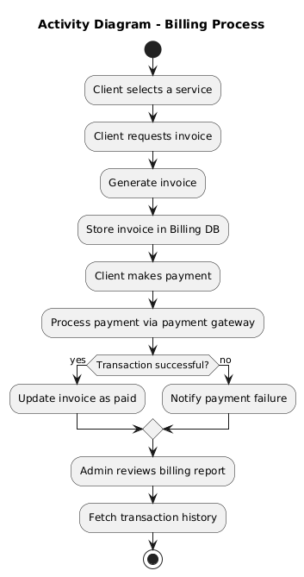

Manage billing

4.2.3 Sequence Diagrams

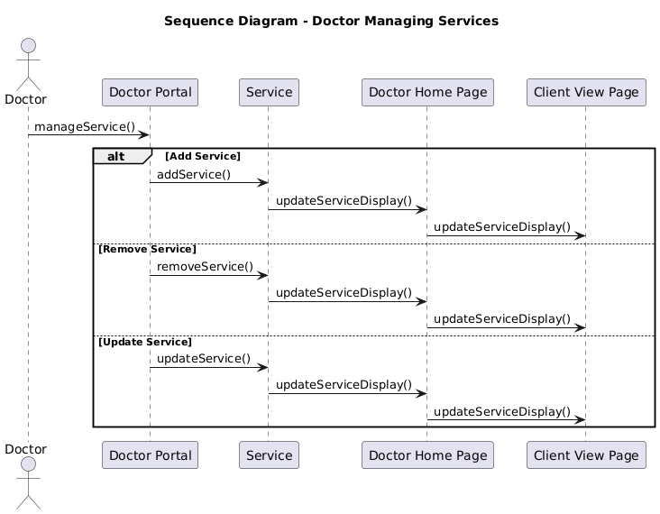

Making an appoinment

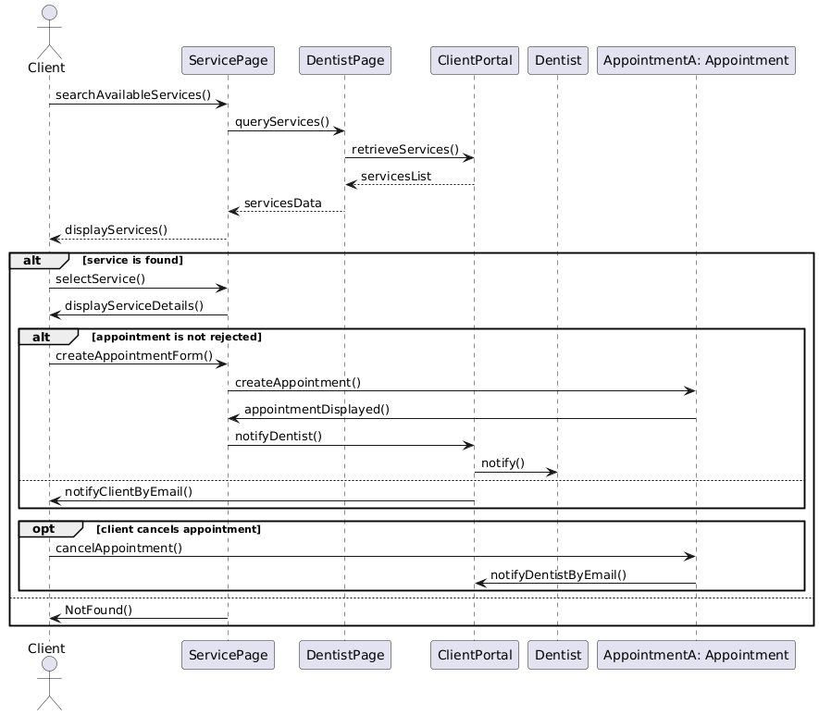

Leaving a review

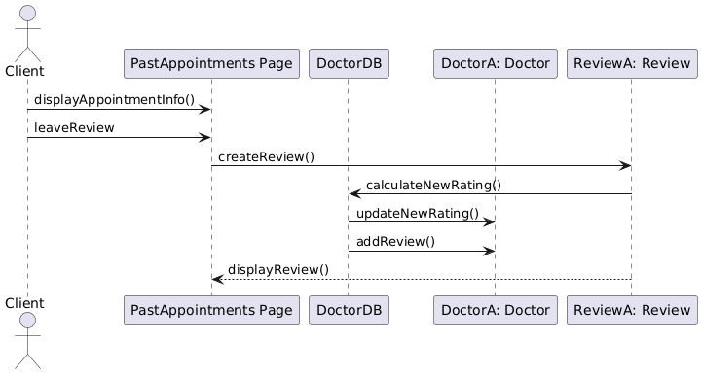  
Reporting a doctor

Sign up/sign in/ update/delete client

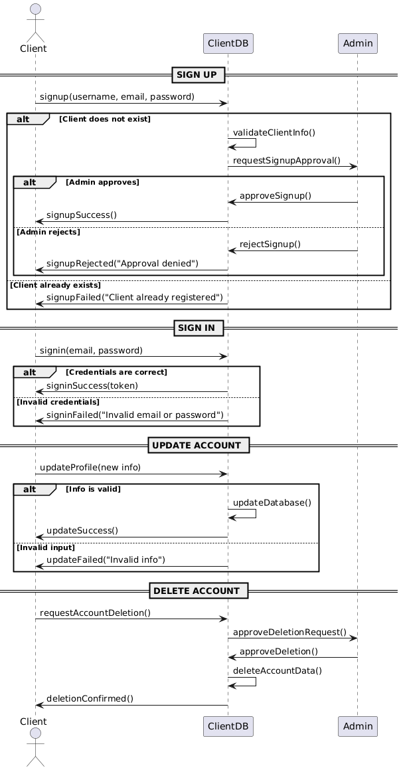

Admin sign in/ sign up/ update/ delete

Doctor sign in/ sign up/ update/ delete

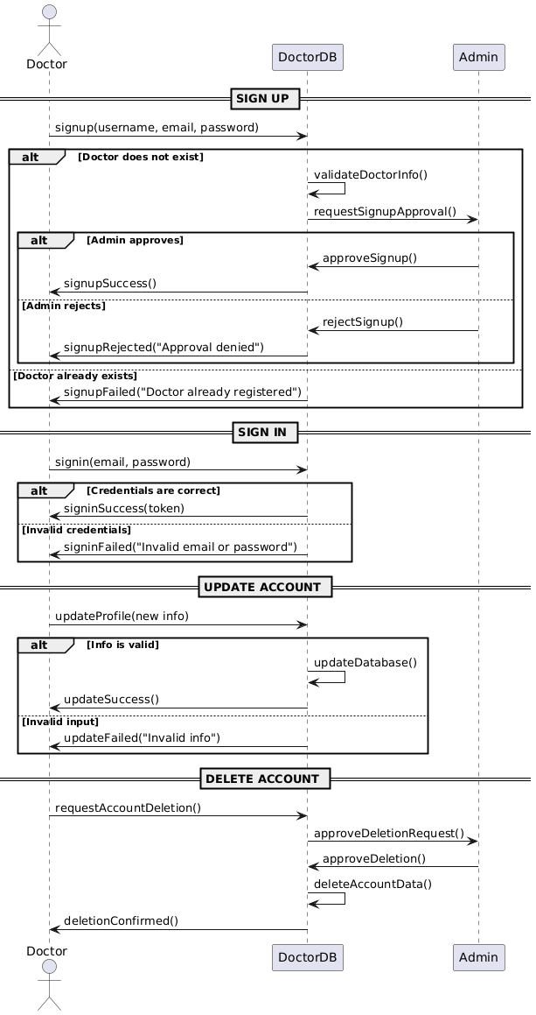

Manage billing

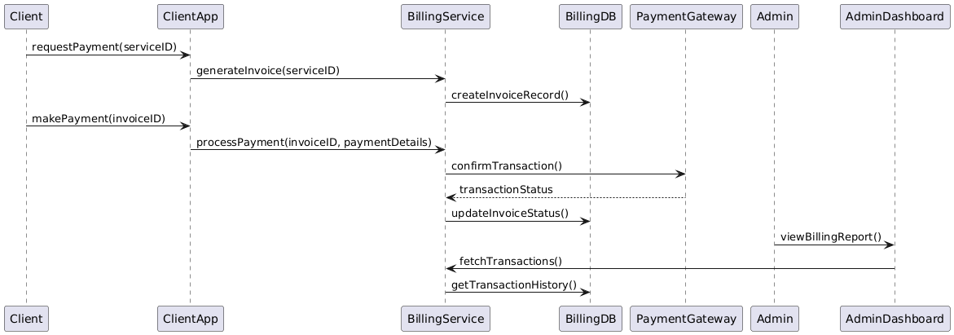

***4.3 Entity Relation***

***4.3.1Database Schema Design***

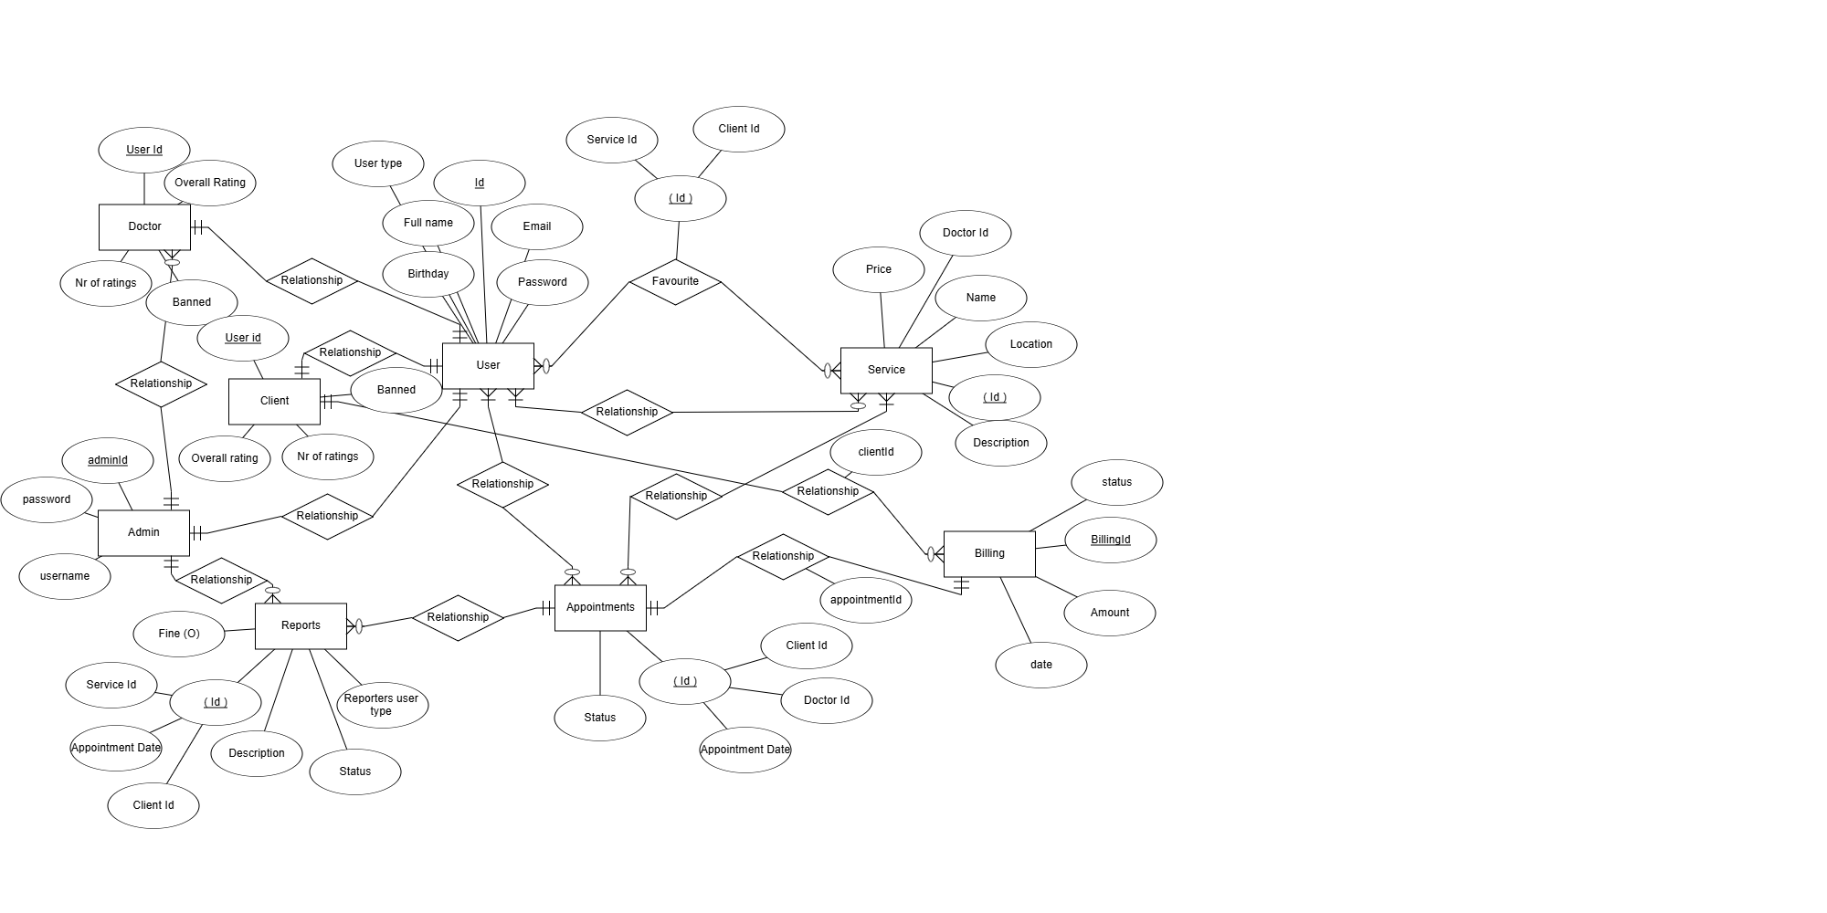

4.4 Structural Diagrams

4.4.1 Class Diagram

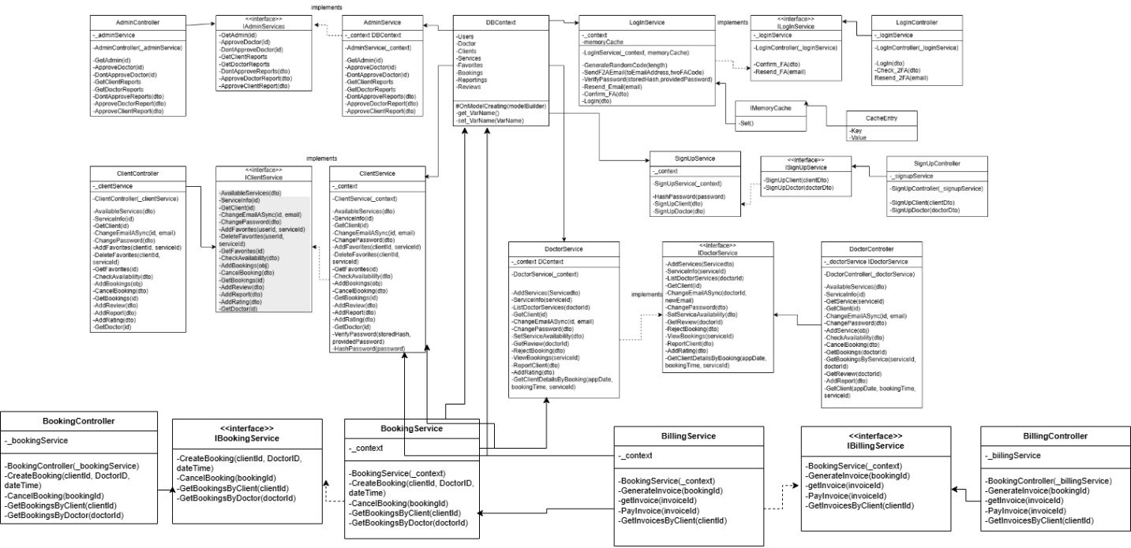

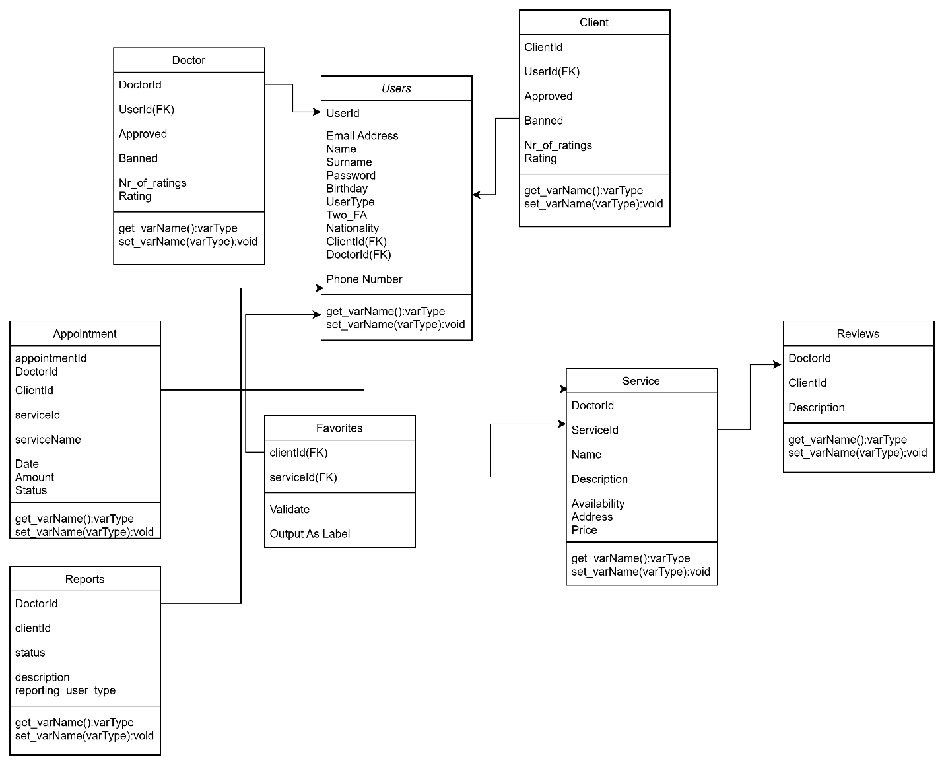

4.4.2 Component Diagram

**5. IMPLEMENTATION TECHNOLOGY**

**Backend: .NET**Epoka Dental Clinic utilizes the .NET framework for backend development. .NET provides a robust, scalable, and high-performance platform for building web applications. Its extensive libraries and tools facilitate rapid development and deployment, ensuring a reliable and efficient backend architecture for our application.

**Database: MySQL**

For local data storage, Epoka Dental Clinic employs MySQL, a widely-used relational database management system. MySQL is known for its reliability, scalability, and ease of use, making it an ideal choice for handling the complex data structures and relationships inherent in our application. It allows for efficient data management and retrieval, ensuring a seamless experience for users.

**Frontend: React**  
The frontend of Epoka Dental Clinic is built using React, a popular JavaScript library for building user interfaces. React enables the creation of dynamic and responsive web applications with a component-based architecture. This allows for reusability and maintainability of code, making it easier to manage and scale the application as it grows.

**Mapping: Google Maps API**  
To provide users with an interactive and informative map experience, Epoka Dental Clinic integrates the Google Maps API. This API allows us to embed maps into our application, offering features such as location search, detailed geographical information, and route planning. The Google Maps API enhances the usability of Epoka Dental Clinic by helping users visualize clinic locations and navigate the surrounding areas effectively.

**Design: Figma**  
Figma is used for designing the user interface of Epoka Dental Clinic. As a collaborative interface design tool, Figma allows our team to create, share, and iterate on designs in real-time. This ensures consistency and alignment in our design process, making it easier to translate design prototypes into functional UI components.

**Communication: Slack**  
Slack serves as the primary communication platform for the Epoka Dental Clinic team. With its real-time messaging, file sharing, and integration capabilities, Slack enables efficient collaboration and coordination among team members. This helps streamline our workflows and ensures that all team members stay updated on project developments.

**6. Project Planning**

**Overview**

The planning phase for the Epoka Dental Clinic project involved a series of structured meetings to define, distribute, and track the progress of tasks essential for developing our Airbnb-like web application. Below is a summary of the key decisions, tasks, and milestones discussed during these meetings.

**Meeting Summaries**

**Initial Meetings**

* Topics Discussed: Project layout, focus areas for each team member, system infrastructure, and database.
* Decisions Made: The web application will be named Epoka Dental Clinic. An initial project layout was drafted, detailing the pages for guests, hosts, and admins.
* Tasks Assigned: Research ways to enhance database efficiency and create a preliminary website design using Figma.

**Requirements Definition**

* Topics Discussed: Functional, non-functional, and domain requirements.
* Decisions Made: Filtered and refined the requirements, with an understanding that changes might occur.
* Tasks Assigned: Improve database structure and collaboratively finalize requirements.

**Requirements Division**

* Topics Discussed: Division of requirements among team members.
* Decisions Made: Finalized the parts/subtopics of the requirements document for the final project presentation.
* Tasks Assigned:
  + Functional Requirements: Luis Seferaj
  + Non-Functional Requirements: Gesajn Celiku
  + Domain Requirements: Erli Halili

**Design Phase**

* Topics Discussed: Progress on assigned tasks and preparation for software designs.
* Decisions Made: Continued with local database for now, research for cloud alternatives ongoing.
* Tasks Assigned:
  + User Interface Design (Figma): Front-End Team
  + Google Maps and Drive API Research, Backend Reorganization: Back-End Team
  + Specific Page Implementations:
    - Admin Page Backend: Erli Halili
    - Client Page/Login/Signup Backend: Luis Seferaj
    - Host Page Backend: Gesjan Celiku

**Progress Check**

* Topics Discussed: Ongoing task updates, front-end and back-end improvements.
* Decisions Made: Continued with existing tasks, no new assignments.
* Tasks Reiterated: Same as the previous meeting.

**Final Wrap-Up**

* Topics Discussed: Final project steps, review of each member’s work.
* Decisions Made: Reviewed and finalized individual contributions, ensured all tasks were completed.
* Tasks History: Summarized the completed tasks and contributions of each member.
* Final Note: No further meetings scheduled.

**Conclusion**

Throughout the project planning phase, the X-Men team demonstrated a collaborative and systematic approach to defining and executing the tasks necessary for the successful development of Epoka Dental Clinic. Each member contributed to various aspects of the project, ensuring a balanced distribution of work and thorough preparation for the final implementation.